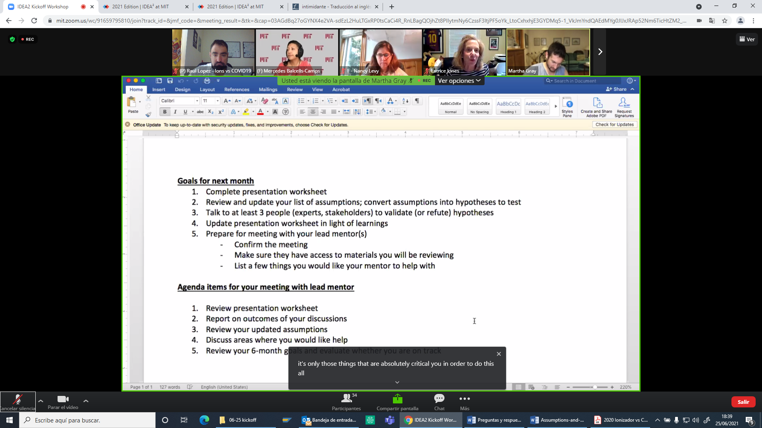

3 months goal (ASAP) | 6 months goal
- 1 prototype in a Bus from a Spanish corporation, biology tested not only for SARS-CoV-2 & Influenza if not for tuberculosis  - 1 prototype in a Metro Wagon but not tested  - Identify company that could do a market analysis plan for product  - Connect with stakeholders, identifying end-users:  - Users: transportation companies, large buildings, air-conditioning companies, hospitals & pharmacies, supermarkets, residences …  - Search interest not only for air-conditioning if not by corporations of ventilation  - Identify advantage over competition.  - Why is better that idea compared to others?  - What we offer than others don’t | - With the information about evolution of SARS-CoV-2 pandemic, and interest on others respiratory pathogens such as Tuberculosis, we will have a clear perspective of the evolution of product.  - Normalize technology to have a product  - To find external economic support  - Patent will be approved  - Prototype of Wagon will be tested by Biology Department  - Test if regulatory restrictions exists for technology  - Outsource market analysis plan

